What the Post Office’s Earnings Mean for FedEx and UPS

By Al Root
Feb. 7, 2020 8:05 pm ET

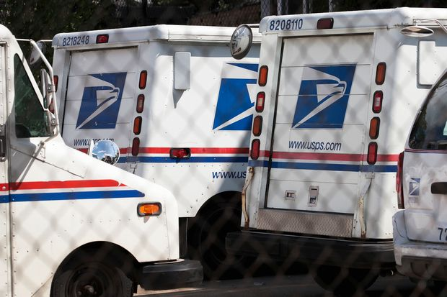
Photograph by Scott Olson/Getty Images

The U.S. Postal Service reported another quarterly loss Thursday. These persistent accounting losses are one reason change might come to the post office—change that can impact publicly traded logistics peers including FedEx and United Parcel Service.

The USPS lost $748 million from $19.4 billion in sales during the fourth quarter. (The fourth calendar quarter is the first fiscal quarter for the post office.)
There are no analyst estimates to compare USPS sales and earnings against. No one covers the USPS as they do publicly traded logistics providers. But the USPS matters—or should matter—to investors.

For starters, it’s big. Logistics peers UPS (ticker: UPS) and FedEx (FDX) generated $20.6 billion and $17.3 billion in sales, respectively, during their most recently reported quarters. That’s similar to what the post office generates. Actions the USPS takes—such as pricing or investment decisions—impact the entire U.S. logistics network.

What’s more, USPS package volume numbers are an important data point for the e-commerce industry.
Post office package volumes declined about 5% year over year during the final quarter of 2019. The decline, however, doesn’t mean consumers weren’t spending. Instead it is a reflection of insourcing volumes by customers who once used the USPS.
The post office wouldn’t comment on which customers are insourcing volume or what e-commerce pricing was doing.
Amazon.com (AMZN) and FedEx are the companies most stakeholders point to when identifying the reason for lost volumes. FedEx, for its part, announced in May 2019 it was taking back “SmartPost” volumes formerly delivered to the USPS.

USPS’s volume declines are evidence that the last-mile delivery war is still hot. Everyone from Amazon to Walmart (WMT) want to deliver e-commerce packages. The key to winning the war is to have enough volume to spread over a consumer delivery network. That’s, presumably, why FedEx took back “SmartPost” volumes.

Volume competition is bad for the industry, but USPS package sales grew about 2%. Pricing is up. What’s more, CEO Brennan indicated the post office would continue to increase prices, where it could, to help offset losses.

That’s a positive for the industry. Increasing package pricing is one sign that—while competitive—e-commerce delivery players are tethered to economic reality.
Those are the most immediate impacts USPS numbers have on publicly traded players. The longer term competitiveness of the post office matters too. Its ability to invest and grow is, in part, restricted by unique accounting rules.
The USPS loss always looks larger than it would for a publicly traded firm. Congress mandates the USPS pre-fund retiree health care obligations. Those aren’t pensions; most U.S. firms pre-fund pensions by law. Health care benefits are funded on a pay-as-you-go basis by the vast majority of firms.
The retiree accounting treatment continues to be a sore spot for USPS stakeholders.
“The Postal Service’s financial report for the first quarter of fiscal 2020 underlines the need for congressional action on common-sense legislative reform,” said National Association of Letter Carriers President Fredric Rolando in an emailed statement to Barron’s. “The entire first quarter loss—$748 million—stems from the unfair obligation placed on the Postal Service by Congress in 2006 to pre-fund [health benefits] in advance.”

The accounting change doesn’t impact reported cash flow, but Congress’s accounting treatment does matter. Congress wants cash flow preferentially diverted to benefits instead of, say, investment in technologies to make the USPS even more efficient.
The comparable number for S&P 500 companies is, roughly, $1 trillion. If the rules governing the post office governed the S&P 500, its member companies would have to raise, very roughly, $1 trillion to pre-fund post retirement benefits.

The math is complicated. Prefunding with, say, debt would cut cash expenses—the annual benefits paid—while raising interest expenses—incurred form the new debt. In theory, little changes. But high debt levels would influence debt ratings and investment decisions.
There is also the psychological impact reporting losses has on the USPS. It can’t be easy to constantly refer to large losses. Especially when losses aren’t as large as people think.
And the post office has a universal service mandate. Americans get their first class mail for the price of a forever stamp no matter where they live. And the price of the stamp on that mail is, essentially, set by politicians.

